**ASSIGNMENT 5**

**1.Study about Static blocks and push 1 example code on github.**

package assignment5;

import java.util.Scanner;

class CreateStaticBlock{

Scanner s= new Scanner(System.in);

static int a;

int b,sum;

CreateStaticBlock(){

System.out.println("Enter the integer value for a static variable a: " );

a=s.nextInt();

System.out.println("Enter the integer value for variable b: " );

b=s.nextInt();

}

void sum() {

System.out.println("The Sum of a and b is Sum=: "+ (a+b));

}

static {

System.out.println("The static block starts here.");

System.out.println("Here initialize the value of the static variable a.");

a=10;

System.out.println("The value of the static variable a is: a="+a);

System.out.println("The static block ends here.");

}

}

public class StaticBlocks {

public static void main(String arg[]) {

CreateStaticBlock stat=new CreateStaticBlock();

stat.sum();

CreateStaticBlock stat2=new CreateStaticBlock();

stat2.sum();

}

}

**OUTPUT:**

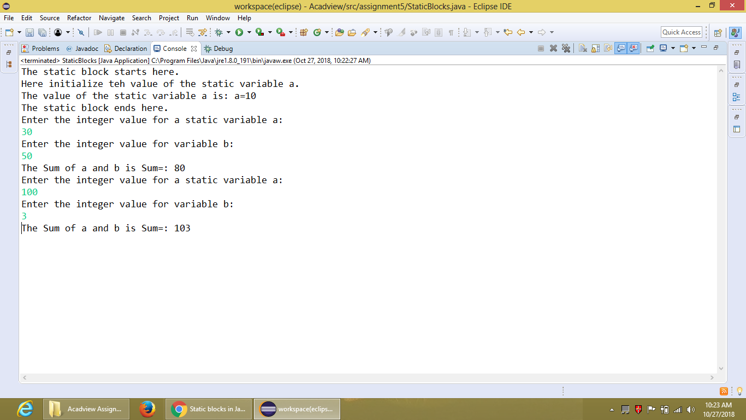

**2. Make Class Animal(with properties breed and colour and function speak()), class Dog and class Cat. Dog and Class inherit from Animal class.You need to override speak function of Animal Class.**

package assignment5;

import java.util.Scanner;

class Animal{

Scanner s=new Scanner(System.in);

String breed,color;

Animal(){

System.out.println("What is the breed of the animal: ");

breed=s.nextLine();

System.out.println("What is the color of the animal: ");

color=s.nextLine();

System.out.println("The breed of the animal is: "+breed);

System.out.println("The color of the animal is: "+color);

}

void speak() {

System.out.println("How the animal speak ?");

}

}

class Dog extends Animal{

void speak() {

System.out.println("The dog bark as 'bow-wow'.");

}

}

class Cat extends Animal{

void speak() {

System.out.println("The cat speak as 'mmmnnawwww'.");

}

}

public class OverrideSpeakFunction {

public static void main(String arg[]) {

Dog d=new Dog();

d.speak();

Cat c=new Cat();

c.speak();

}

}

**OUTPUT:**

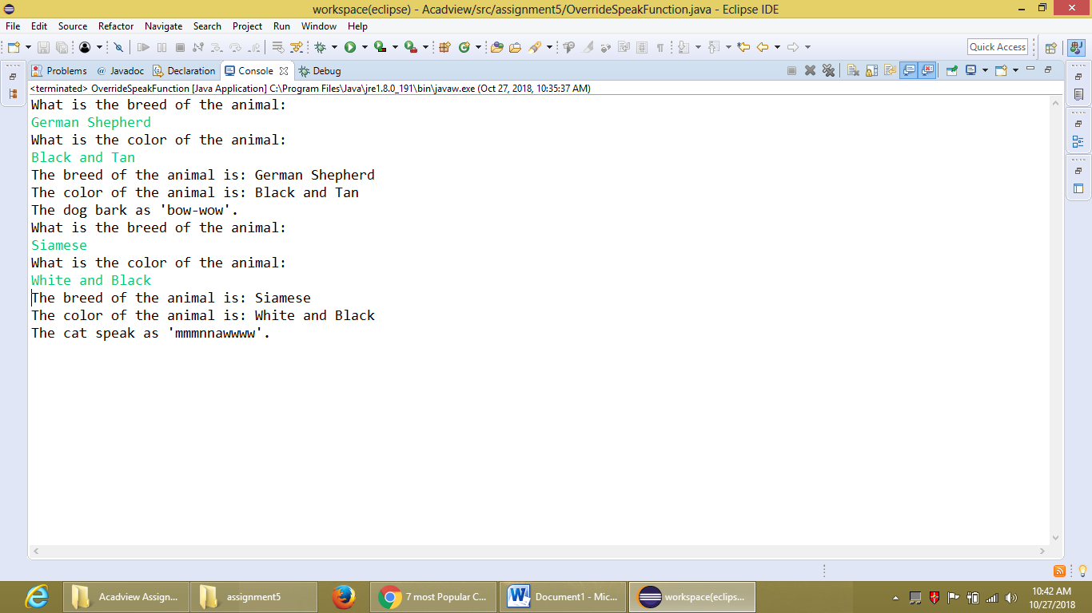

**3. Overload Print function to accept Null arguments , one integer , one float.**

package assignment5;

class PrintFunction{

void print() {

System.out.println("The Print() with Null arguments.");

}

void print(int n) {

System.out.println("The Print() with one integer argument and given integer is:

"+n);

}

void print(float f) {

System.out.println("The Print() with one float argument and given float is: "+f);

}

}

public class OverloadPrintFunction {

public static void main(String arg[]) {

PrintFunction p=new PrintFunction();

p.print();

p.print(17);

p.print(34.6f);

}

}

**OUTPUT:**

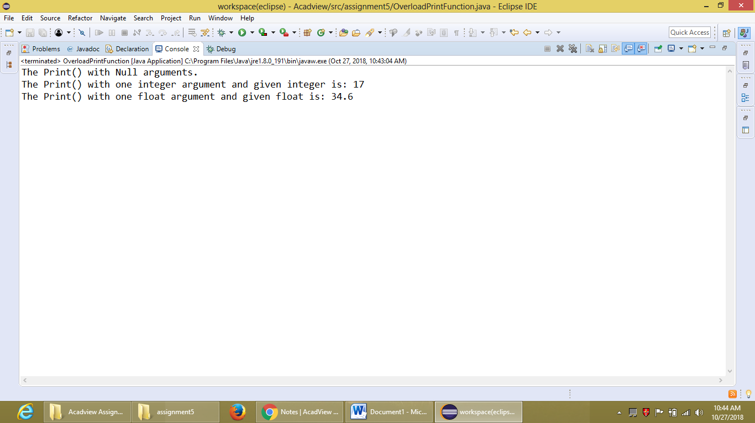

**4. Make 2 classes twowheeler and fourwheeler(both having 2 functions- start() and stop()) and both inherit from abstract class Vehicle. Vehicle has 2 functions(void abstract start() and void stop()).**

**Print start and stop details of both classes(twowheeler and fourwheeler).**

package assignment5;

abstract class Vehicle{

abstract void start();

void stop() {

System.out.println("The Vehicle is stopping.");

}

}

class TwoWheeler extends Vehicle{

void start() {

System.out.println("The Two Wheeler Vehicle is starting.");

}

}

class FourWheeler extends Vehicle{

void start() {

System.out.println("The Four Wheeler Vehicle is starting.");

}

}

public class InheritAbstractClass {

public static void main(String arg[]) {

TwoWheeler t=new TwoWheeler();

t.start();

t.stop();

FourWheeler f=new FourWheeler();

f.start();

f.stop();

}

}

**OUTPUT:**

